**Evaluation Summary**

This document shall outline the findings from the evaluation process, undertaken for the Graphical Enigma simulator, and the required information about the participants from the demographic questionnaire.

|  |  |  |  |
| --- | --- | --- | --- |
| *Participant ID* | *Age* | *Previous Knowledge of Enigma Machine* | *Operating System most used* |
| 01 | 22 | Yes | Windows |
| 02 | 22 | No | Windows |
| 03 | 24 | Yes | Windows |
| 04 | 21 | Yes | Windows |
| 05 | 70 | Yes | Windows |
| 06 | 22 | No | Windows |
| 07 | 23 | No | Windows |

Unfortunately participants who used a different operating system other than Microsoft Windows were not able to be recruited. It was beneficial however that not all of the participants were not students, one was a staff member.

Another benefit was the diversity of the participants in regards to having previous knowledge of the Enigma machine.

The participants were asked to carry out the operations of encrypting and decrypting text and to see whether or not the understood the process which is happening. Once they had done this task they were asked to complete the SUS (System Usability Scale) Questionnaire.

The data from the SUS questionnaires for each participant has been extracted in the form of a spreadsheet using Microsoft Excel (Appendix P).

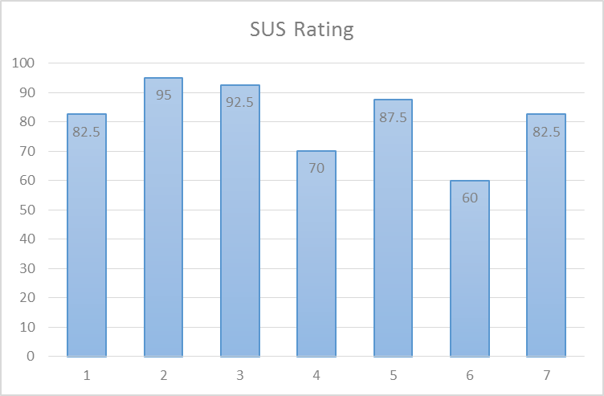

*Graph 1 – SUS Rating*

The above graph shows the SUS rating for all 7 participants.

Based on the average value from the scores, 81, anything above that value is deemed above average, and anything below is below average. Also the scale is 0-100 but should not be interpreted as percentages. However normalizing the data and creating a percentile ranking would be better, but doing this with less than 10 participants would not tell us too much. Taking this into account, a custom grading system was used.

50 < F; 60 < C; 70 < B; 80 < A; 90 > A+;

F – fail, C – adequate usability, B and A represents that it is good usability, A+ would mean they would recommend the simulator to a friend.

Based on the above grading system, none of the participants failed, while two were on the border of C and B. Therefore with majority of the participants scoring A or above, it can be concluded the simulator overall is usable.

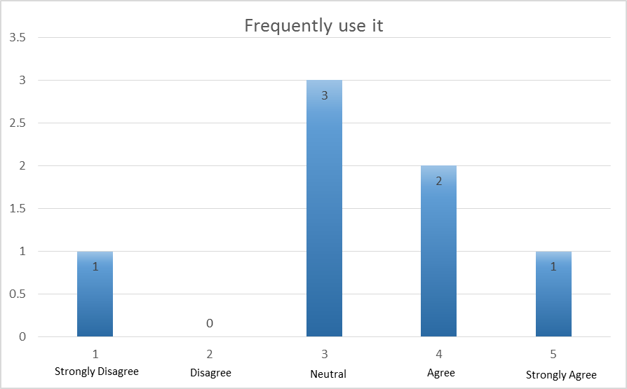

*Graph 2 – Frequently use it*

Graph 2 above shows how many of the participants would frequently use the simulator. Having spoken to them not many had a great interest in Enigma machines as such, but asked if they had to use it would they? They responded positively and said they would consider using it.

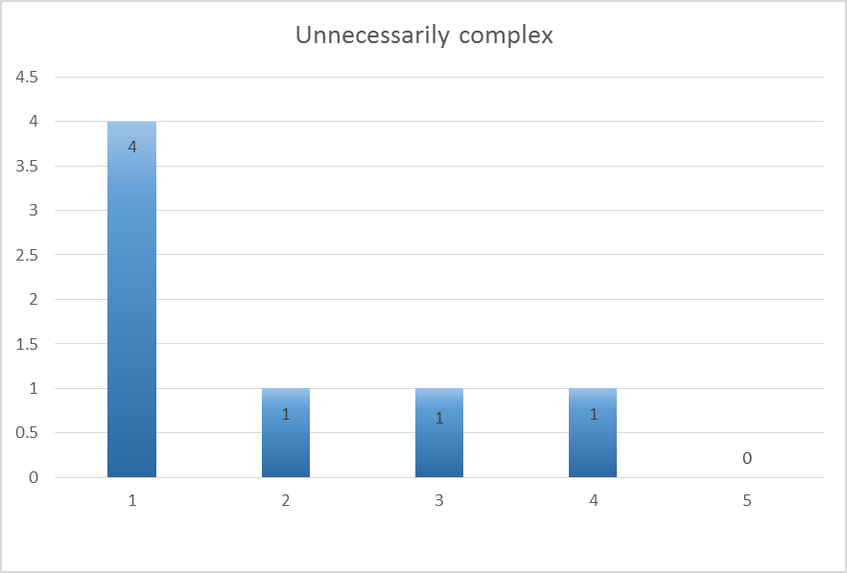

*Graph 3 – Unnecessarily Complex*

Another factor while developing the simulator was to ensure it was developed as simple as possible for users to interact with. Again majority of the participants found it was very straight forward. However one did report to find it somewhat complex.

No further questions were asked to the participants who reported in the questionnaire that it was complex to use so no conclusions can be drawn.

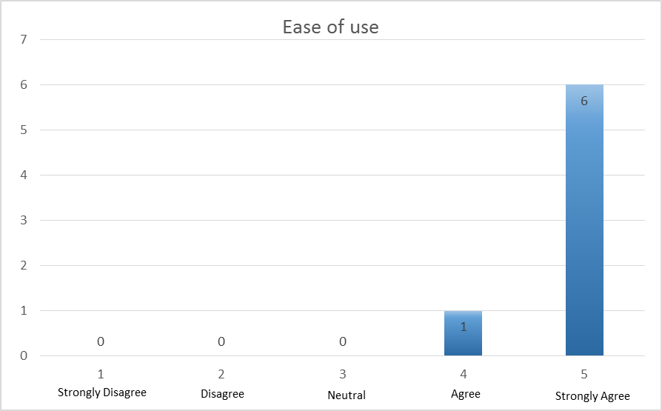

*Graph 4 – Ease of use*

Ease of use, Graph 4 above, was one of the most important factors while undertaking evaluation. The ease of use was vital for usability. Every participant seemed to find it easy to use. This was demonstrated while observing them using the simulator. These results reflect the simplicity of the interface.

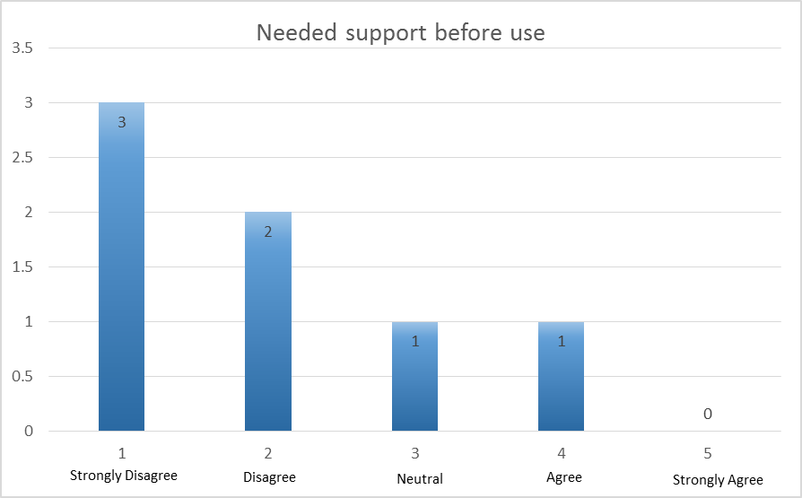

*Graph 5 – Needed Support Before use*

The fact that most participants were able to use the simulator with very little input from the researcher was insightful. However again one did need some assistance.

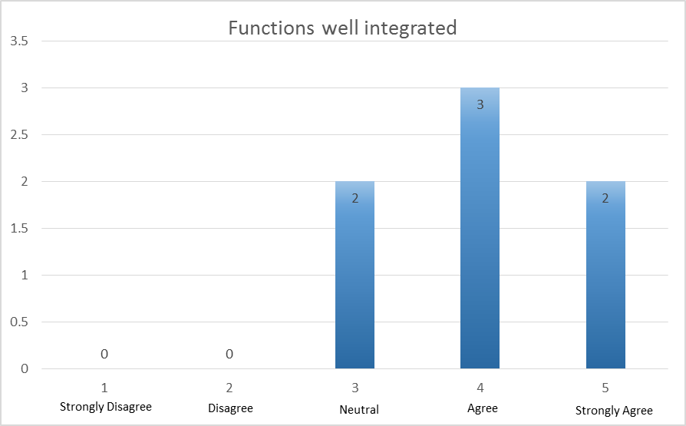

*Graph 6 – Functions well Integrated*

Majority of the participants agreed that the functions had been well integrated into the simulator. Some thought perhaps more work should have been done to ensure the components were pixel perfect and to provide a greater insight of the processes.

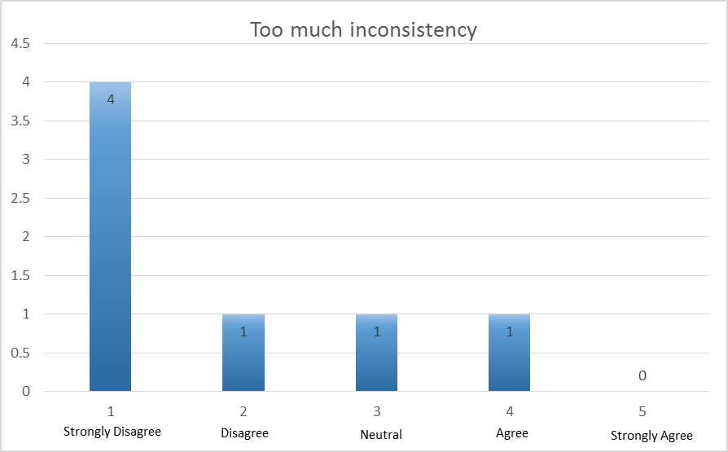

*Graph 7 – Too much Inconsistency*

Majority of the participants thought that the simulator was fairly consistent throughout. Again one thought some inconsistencies existed but no further information was drawn from that participant.

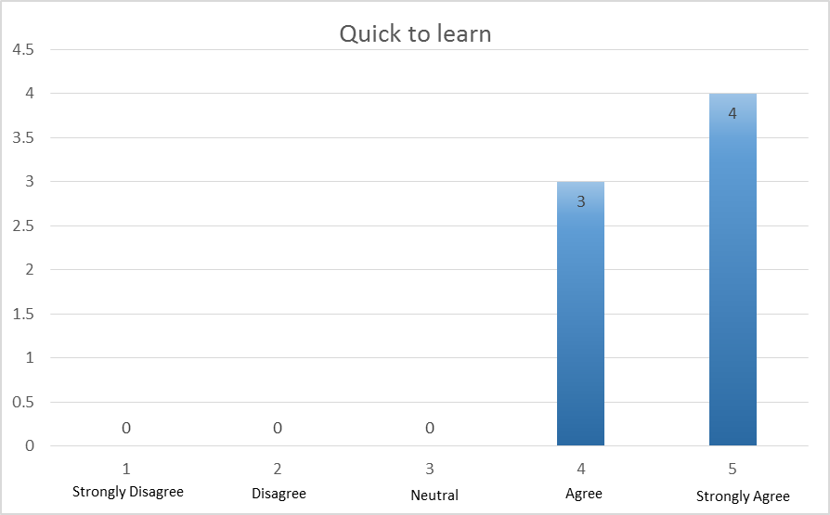

*Graph 8 – Quick to Learn*

How quick the simulator is to learn, Graph 8, is an important factor. All of the participants agreed it was easy to learn. This reflects the simplicity of the interface as well as demonstrating how well the design of simulating the processes of encryption and decryption.

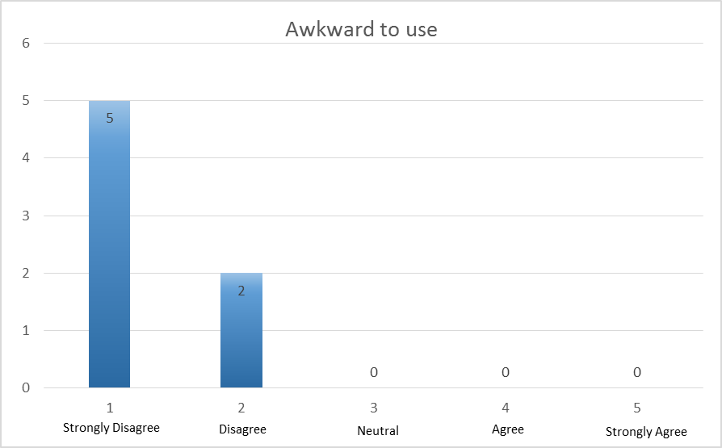

*Graph 9 – Awkward to use*

All of the participants felt comfortable using the simulator, which was demonstrate further while observing them.

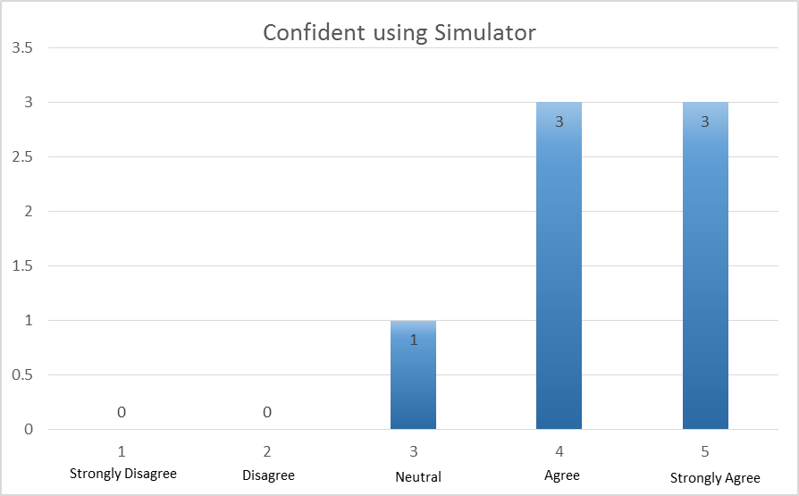

*Graph 10 – Confident using Simulator*

This graph above contrasts with Graph 9, majority of the participants felt confident while using the simulator with little or no problems.

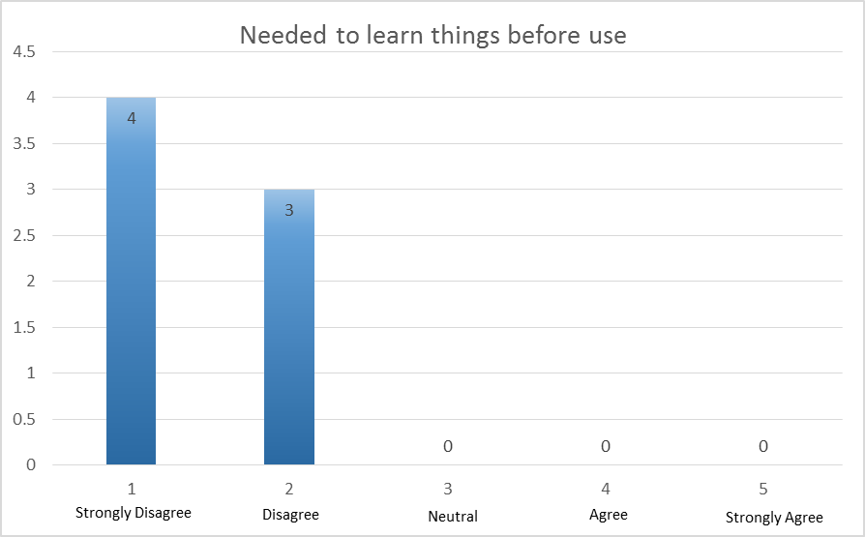

*Graph 11 – Needed to learn things before use*

All of the participants agreed that they did not require previous knowledge of the Enigma machine/simulator before using the simulator.

Overall positive feedback was gained from the evaluation process. While one participants responses conflicted with their own it can be gathered they may have misinterpreted the questions. This can be seen from Graph 3 and 4. One participants, before undertaking evaluation, thought the simulator may have been 2D instead of 3D but was impressed with the effort put in to make it 3D. One problem, which did arise with most participants, was that they wanted to copy and paste the text in order to carry out the other function but ended up writing down the text onto paper. One participant had changed the rotor settings and forgot to note down which rotor settings were set so had to go back and carry out the operation again, and write down the text again. An interesting observation made was that none of the participants actually clicked on help. This may have been because they were already told about the simulator, but even then they were not informed that they would be able to look around the rotor. They almost stumbled upon the controls by accident rather than reading what the controls were. This was interesting because having never used the simulator before they were able to quickly grasp an understanding of it.

Throughout development Nielson’s Heuristics were taken into consideration. These considerations aided design decisions and the final design concept of the simulator. There were the following;

*Visibility of system status*

Feedback was provided to the user about the current mode, encryption or decryption. This was done by renaming the title bar to reflect the appropriate mode. Also, to ensure the user knows that the text box is active, an insertion cursor appears. Upon entering a letter to process, the simulator would animate and produce the current path while rotating the required steps. This provided feedback to the users to make them aware that the simulator is performing the process.

*Match between system and the real world*

The choice of wording was chosen carefully, especially in the help section to ensure not too much technical jargon was included. The wording did not confuse any of the participants as they were able to understand the phrases used.

*User control and freedom*

This aspect was important because if the user was to click on the decrypt function instead of the encrypt function they would require a function to allow them to go back to the previous menu. This was taken into consideration immediately as it formed part of the menu navigation. This provides the user with an emergency exit if they were to enter a function by mistake without having to go through an extended interaction. To facilitate this a ‘back to menu’ button was implemented. Another consideration taken into account was what if the user was to erase a letter from the text field, should the rotor reverse one step? The answer was yes because this demonstrates to the user that they have erased a letter as well as the corresponding letter being erased from the opposing text field. This essentially supports an undo function. More considerations could be given to assist users with accidental interactions.

*Consistency and standards*

The theme of the simulator remains constant throughout the interface. The font is always white. Buttons are consistently the same shade of grey. The interface layout for the encryption and decryption functions remained consistent. Another important factor in terms of consistency was the wording, to ensure the same terminology was used throughout. This was to decrease cognitive load on the user to describe certain aspects. None of the participants provided feedback on this aspect, however.

*Error Prevention*

Rather than displaying error messages, it was important to prevent the problem occurring in the first place. An important scenario to address was what if the user was to press backspace, and no text was present in the text field? In this scenario the simulator shows a tooltip. Another scenario would be when viewing the rotor details. Since it is connected with the help section, closing the help section should close the rotor details also and return the user to the previous state. Quite a few bugs were surrounding the backspace key, one of which involves holding the backspace key down. This was more a logical error rather than a user interface side error.

*Recognition rather than recall*

This is an important consideration to ensure minimum cognitive load on the user. To comply with this consideration the encryption and decryption screens remain consistent. This reflected in the evaluation results with all the participants agreeing the simulator was easy to use and quick to learn. This ties in with the *Consistency and Standards* section.

*Flexibility and efficiency of use*

Due to the simplicity of the user interface the simulator caters for novice and experienced users equally. Unfortunately, however, consideration was not given to shortcuts to optimize certain tasks. This is an aspect which could be improved upon.

*Aesthetic and minimalist design*

The interface presented to the user upon entering the encryption or decryption mode included only the necessary information. The ‘show rotor details’ button implemented in the help section was initially designed to be included on the main simulation screen, beside the help button. However, it was thought that this should be included in the help section rather than having an additional button to clutter the interface.

*Help users recognize, diagnose and recover from errors*

The interface and user input fields have been designed to ensure no errors occur. Because the user can only enter letters and not numbers, symbols or utilizing the spacebar, no feedback as such is provided as nothing is entered. This is clearly an aspect which could be improved upon.

*Help and documentation*

Every effort was carried out ensure that the simulator remained intuitive and simple especially in the help section to ensure it was lightweight. However a user guide has been created to assist the user. Whether it is a novice user or an expert user, they can still refer to this guide for assistance. It provides a more in depth guidance than the help section in the simulator and provides more explanations on certain aspects. In addition to a user guide, video tutorials have been created demonstrating each mode being used.

**Requirements**

The set of requirements specified during the start of the project were mostly met. All the requirements which had high priority were all met.

Please refer to the Specification Requirement (Appendix O) document for numbering details.

*Functional Requirements*

The only requirements not met for this section were *R8, R11 and R14*. This was mainly due to time constraints. *R8* and *R11* were designed to include three rotors, like the Enigma machine had. However it was realised that it would be difficult to fit all three on to one screen, within a reasonable size for the user to view. Also time constraints did not allow further development on these requirements.

*R14* was designed to add a type of problem solving game to the simulator, acting like a teaching tool to decrypt the text manually. However it was later realised that this should only be added if there is time, which there was not.

*Non-Functional Requirements*

The only requirements not met for this aspect was *R17*, making the simulator compatible for Mac/Linux. However during user evaluation this did not seem an issue as they all used the simulator on a Windows operating system. However access to a Mac/Linux machine was not found therefore this requirement could not be met. It would have been a good addition to have the simulator running across multiple platforms.

**Re-Design**

Due to the resolution of the backspace bug and the simulator to now facilitate copy and paste, the interface had to be slightly re-designed.

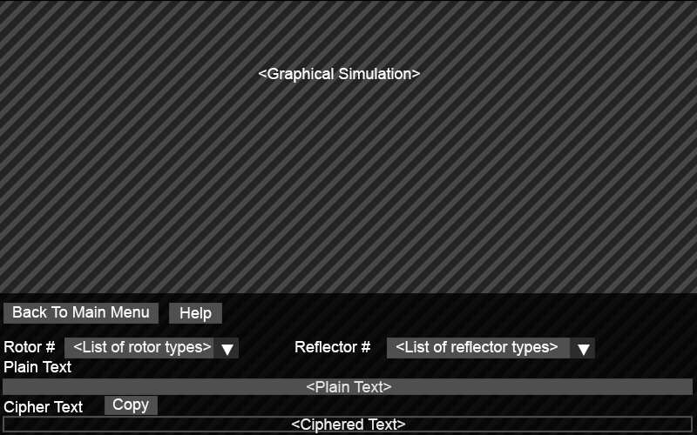

*Figure 1 – Encrypt Screen*

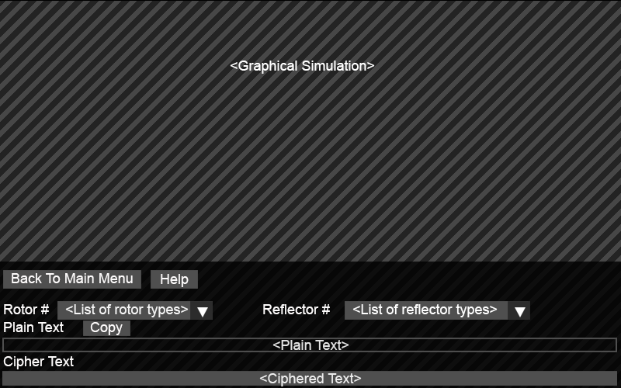

*Figure 2 – Decrypt Screen*

While minimum change was made to the interface, the process of encryption and decryption had to be recoded. This involved the simulator calculating output text each time during the event loop. While this is not evident from viewing the simulator, it can be assumed this would be less efficient from calculating the output on only a key press. To stop it from occurring each time, a Boolean variable was added for it to occur only on a key press so they whole string is processed upon a key press. While facilitating for copy and paste, the backspace bug was fixed. However, one bug which could not be resolved was when a key is held down.

**Conclusion**

Overall the evaluation process has provided an excellent insight on how well the simulator has been developed. With plenty of positive feedback to take on board, future development of the simulator may be minimal.